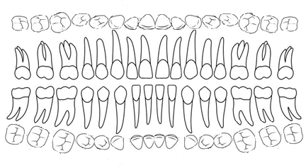

Carie

Fracture

Lyse



Espace

Absente



Réaction Apical



Traitement canalaire

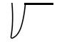

Racine



Version ML



Rotation ML

S

Soigner

P

Palatine

L

Linguale

M

Distale

D

Mestiale



|  |  |
| --- | --- |
| **OC** | **PSE** |
|  |  |
| **PATHO** | **PARO** |
|  |  |

|  |
| --- |
| **Diagnostique** : Squelettique / Alvéolaire / Occlusale / Dentaire |

|  |  |  |
| --- | --- | --- |
| **Bilan** | **Diagnostique** | **Thérapeutique** |
| **……………………………………………**  **……………………………………………**  **……………………………………………**  **……………………………………………**  **……………………………………………**  **……………………………………………**  **……………………………………………**  **……………………………………………**  **……………………………………………** | **……………………………………**  **……………………………………**  **……………………………………**  **……………………………………**  **……………………………………**  **……………………………………**  **……………………………………**  **……………………………………**  **……………………………………** | **……………………………………**  **……………………………………..**  **……………………………………..**  **……………………………………..**  **……………………………………..**  **……………………………………..**  **……………………………………..**  **……………………………………..**  **……………………………………..** |

|  |
| --- |
| **Plan de TRT …………….…………………………..………………………………………………………………..**  **…………………………………………………………..………………………………………………………………..**  **…………………………………………………………..………………………………………………………………..**  **…………………………………………………………..………………………………………………………………..** |